**FPT International School**

--- o0o ---

**PROJECT REPORT**

**Rainwater Harvesting**

Batch: T2010M

Semester: 1

Group:  5

NGUYEN VIET HOANG

NGUYEN MINH TUAN

NGUYEN VAN QUOC

NGUYEN HIEU

              Hanoi - 4/2021

**Table of Contents**

1.  Problem Definition

i.  Introduction

ii. Implementation Environment

User Stories

1.2  Admin

a, Register

b, Manage products

 c, Manage Users

   1.3   Staff

a,Contact/Response                                                                                                                       b, Manage Products

1.4  Customer

a, Personal information

     b, Service about Products & Information

 2. Flowchart

2.1.Register

  2.2. Manage Products

2.3. Manage Categories

     2.4. Manage Users

     2.5. Search Products

  2.6. Purchase Products

3.  UI\UX

3.1Sign in/ up form

3.2.  Home page

3.3       SHOP

3.4.   Commercial

3.5.About

3.6.  Check out form

4. Summary

**1.**     **Problem Definition**

**1.1. Overview**

          i.        Introduction

Rainwater harvesting is a technique used for collecting, storing and using rainwater for landscape irrigation and other uses. The rainwater is collected from various hard surfaces such as rooftops and/or other man made above ground hard surfaces. For a dry climate , rainwater harvesting can make a huge beneficial impact on the environment.

Most rural households have to source all their water on their property, and rainwater often provides a better quality household supply than river, bore or dam water. Rainwater harvesting is not just for rural areas though. Although urban households may be connected to a reticulated, treated (mains) water supply, rainwater harvesting can significantly lower mains water usage.

What are the benefits of rainwater harvesting? It will reduce water bills, provide an alternative supply during water restrictions and help maintain a green, healthy garden. In fact, depending upon tank size and climate, rainwater harvesting can reduce mains water use by 100%. Rainwater harvesting also decreases storm water runoff, thereby helping to reduce local flooding and scouring of creeks.

We are here looking at a website which will provide brief details about few facts and details about rainwater harvesting

The website is supposed to provide user friendly environment and navigation. The important menu must be stated in the top section of the webpage. Also a decent look out and color combination is expected.

The website is to be developed for the Windows Platform using HTML5, JavaScript and Geolocation. The site should work well in all leading browsers including Chrome, IE, Firefox etc.

The Web site is to be created based on the following requirements.

1. The home page about the description/images about various rainwater harvesting techniques should be provided. If user clicks on the same, navigational link must be available.
2. There should be categories providing details about rainwater harvesting in various areas like
   1. Residential area
   2. Commercial area

3.    Under the categories mentioned above, there should be the various products available (well explained about them) as well other techniques that can be applied.

1. The site should also list and explain various facts related and methods that are applied for harvesting
2. There should be a section which will educate people on how to effectively make use of harvested water
3. Also include a section which will provide details on various latest developments in the field of rainwater harvesting
4. Also each link must be properly hyperlinked; images must be used wherever necessary.
5. Contact us page: contact us details with location should be displayed using GeoLocation API (eg. GoogleMaps).

        ii.        Implementation Environment

       -HTML5/CSS/JavaScript

       -Webstorm

       -Google Chrome/ Coc Coc

-Heroku

       -JSON

**User Stories**

**1.2**       **Admin**

        a, Register

        -As an admin I want to register access the database

      b, Manage products

     -As an admin i want to add,removed and update products for my website

      c, Manage Users

      -As an admin i want to add, remove and update users who register to login my website

      -As an admin I want to manage employee information

      -As an admin I want to list orders for customers

**1.3**       **staff**

 a, Contact/ Response

-As an employee I would like to contact the Supplier

b, Manage Products

-As an employee I want to add product classification

-As an employee I want to fix the product classification

-As an employee I want to delete the product category

-As an employee I want to update product categories

**1.4**     **Customer**

   a, Personal information

-As a customer I want to create an account

-As a customer I want to correct personal information

 -As the client I want to log in

-As a customer I want to use the support / Q&A services of the Admin supporter

  b, Service about Products & Information

-As a customer I want to receive notification when an order arrives

-As a client I want to find relevant product information, tools for rainwater harvesting

-As a customer I want to send comments and reviews about the product

-As a customer I want to learn more about service packages

**2. Flowchart**

**2.1.Register**

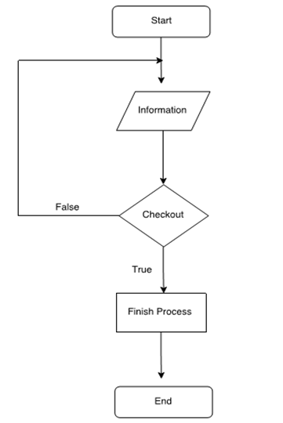

**2.2. Manage Products**

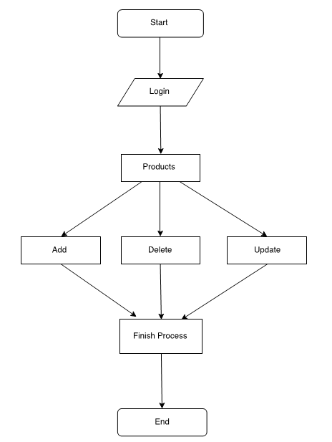

**2.3. Manage Categories**

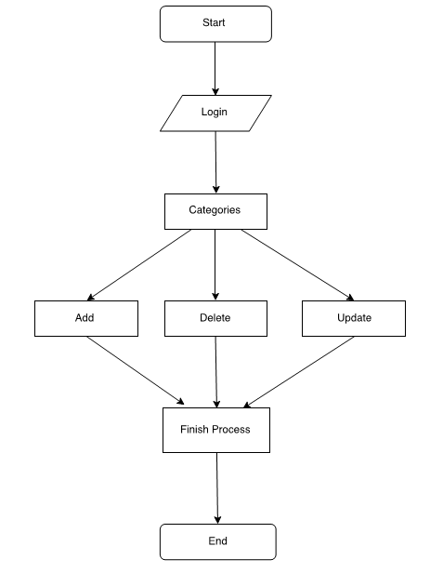

**2.4. Manage Users**

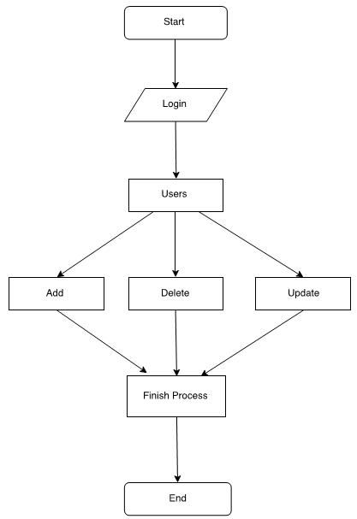

**2.5. Search Products**

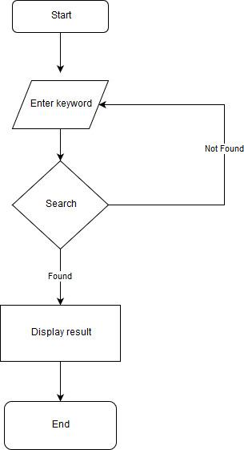

**2.6. Purchase Products**

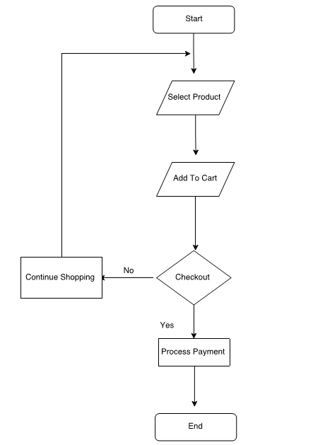

**3.  UI\UX**

**3.1       Sign in/ up form**

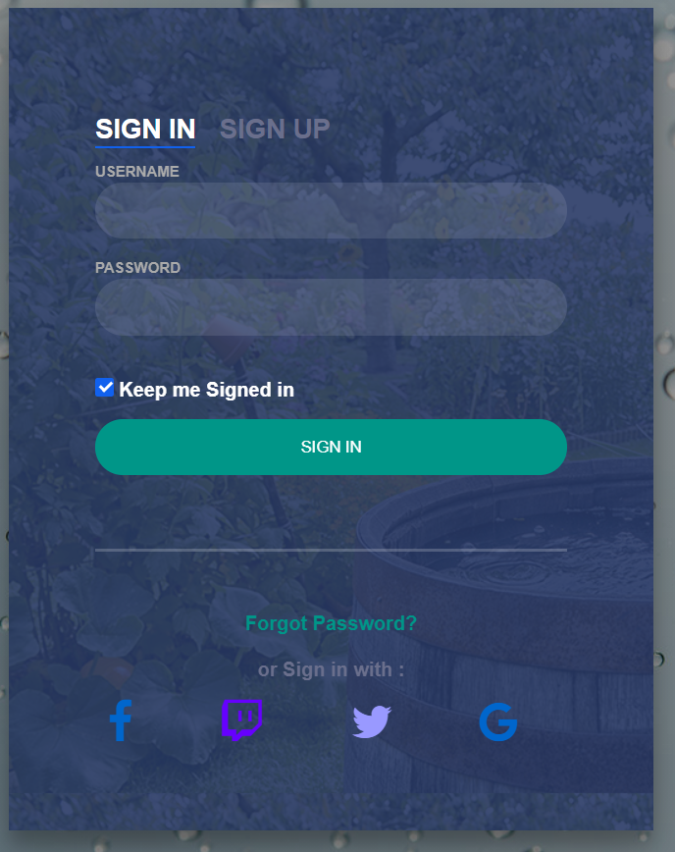

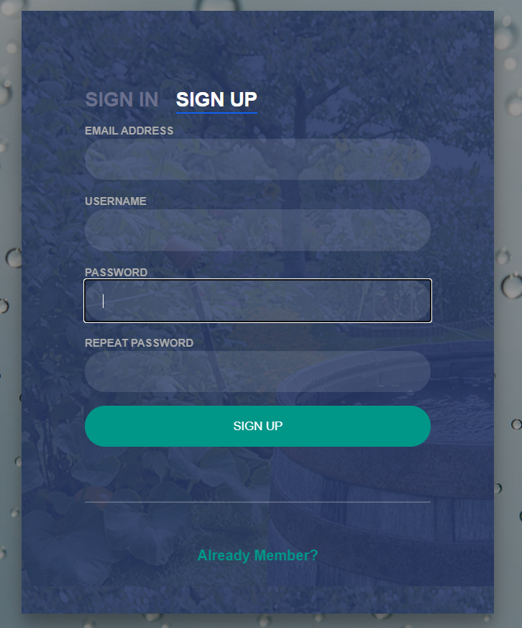

**3.2**.  **Home page**

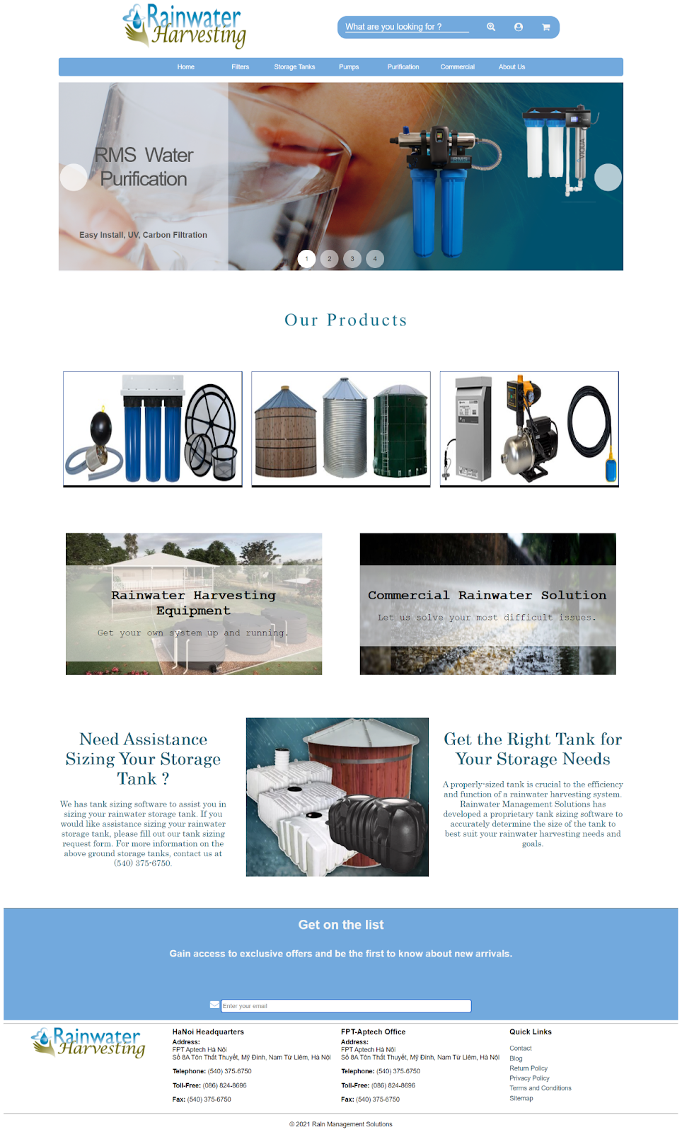

**3.3**       **SHOP**

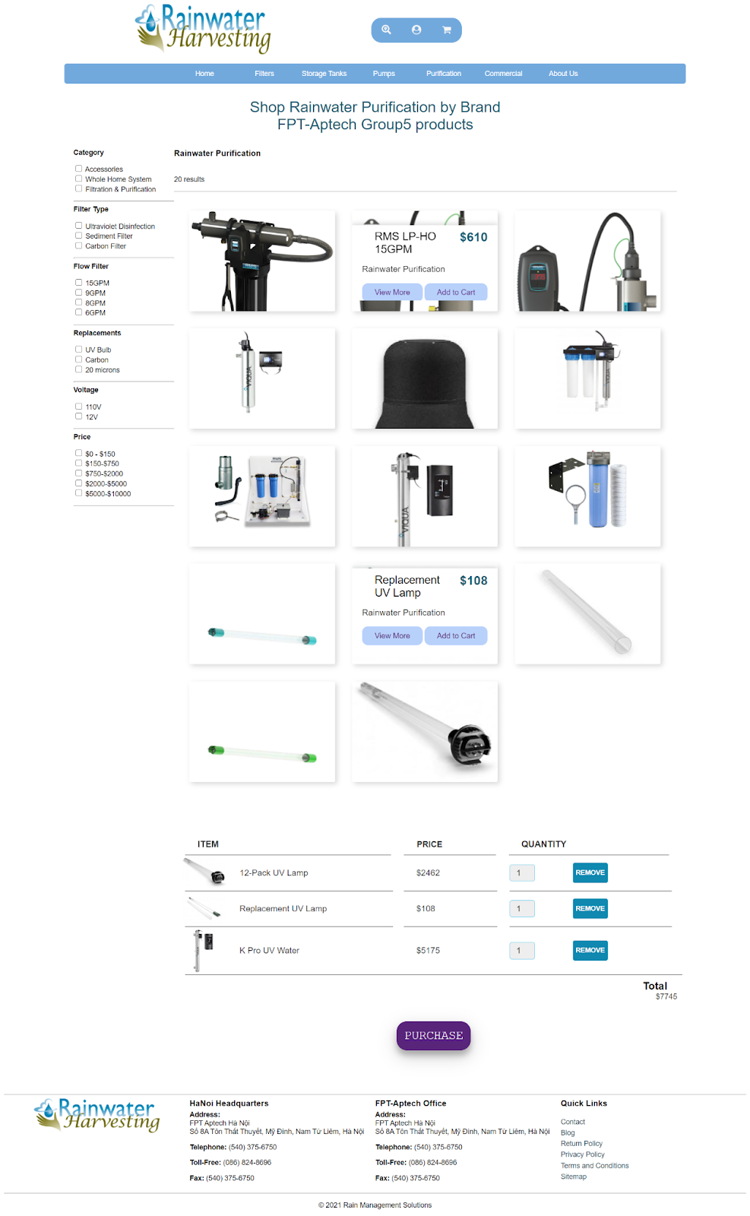

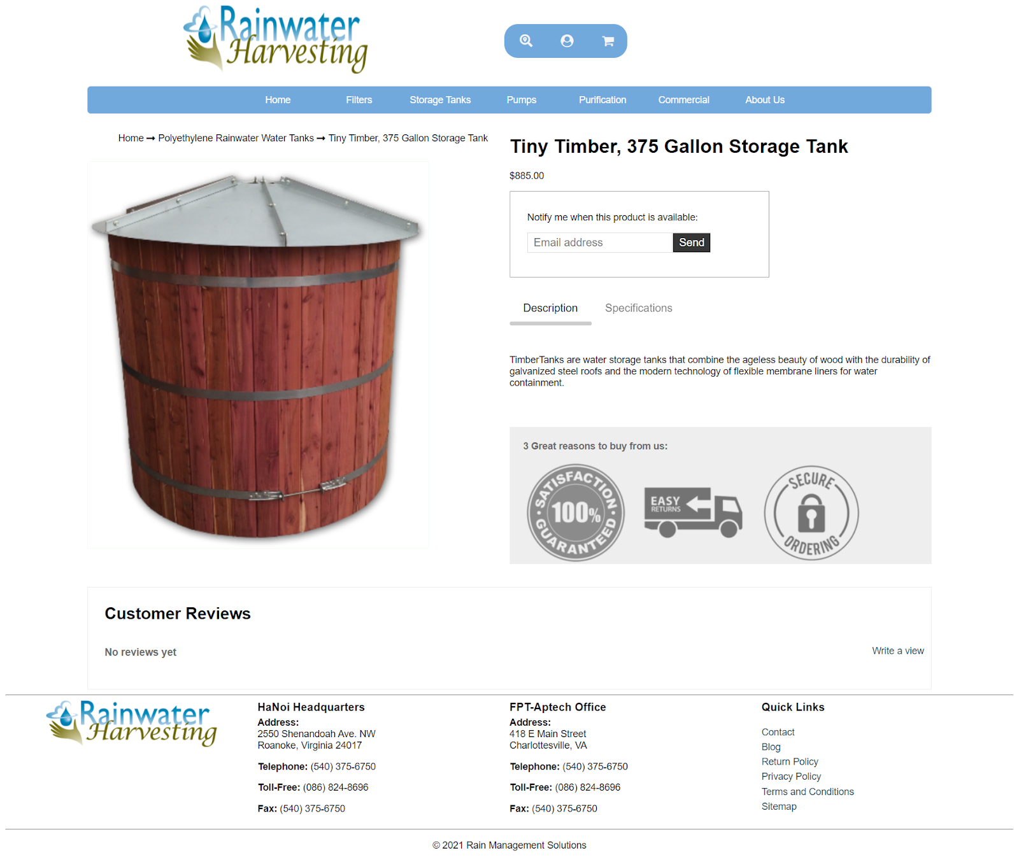

**3.4.   Commercial**

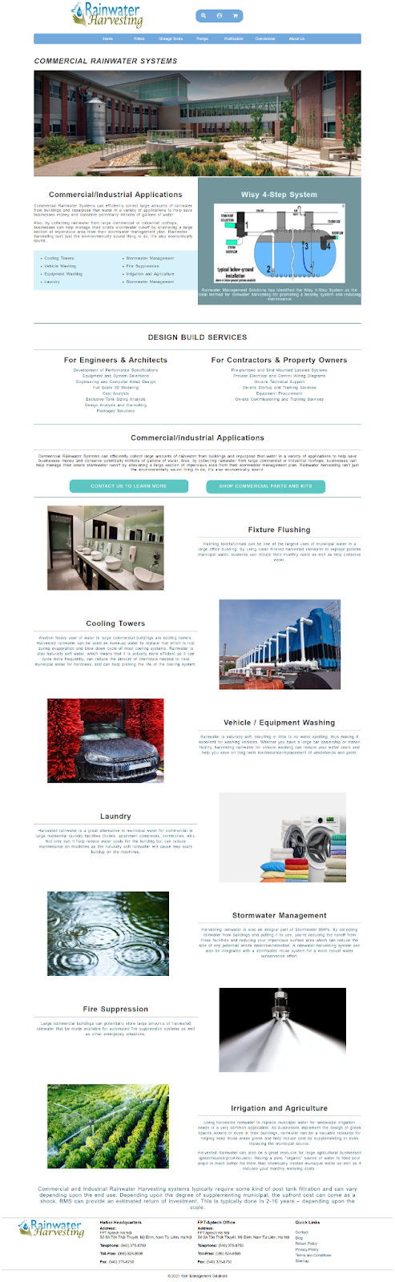

**3.5 . About**

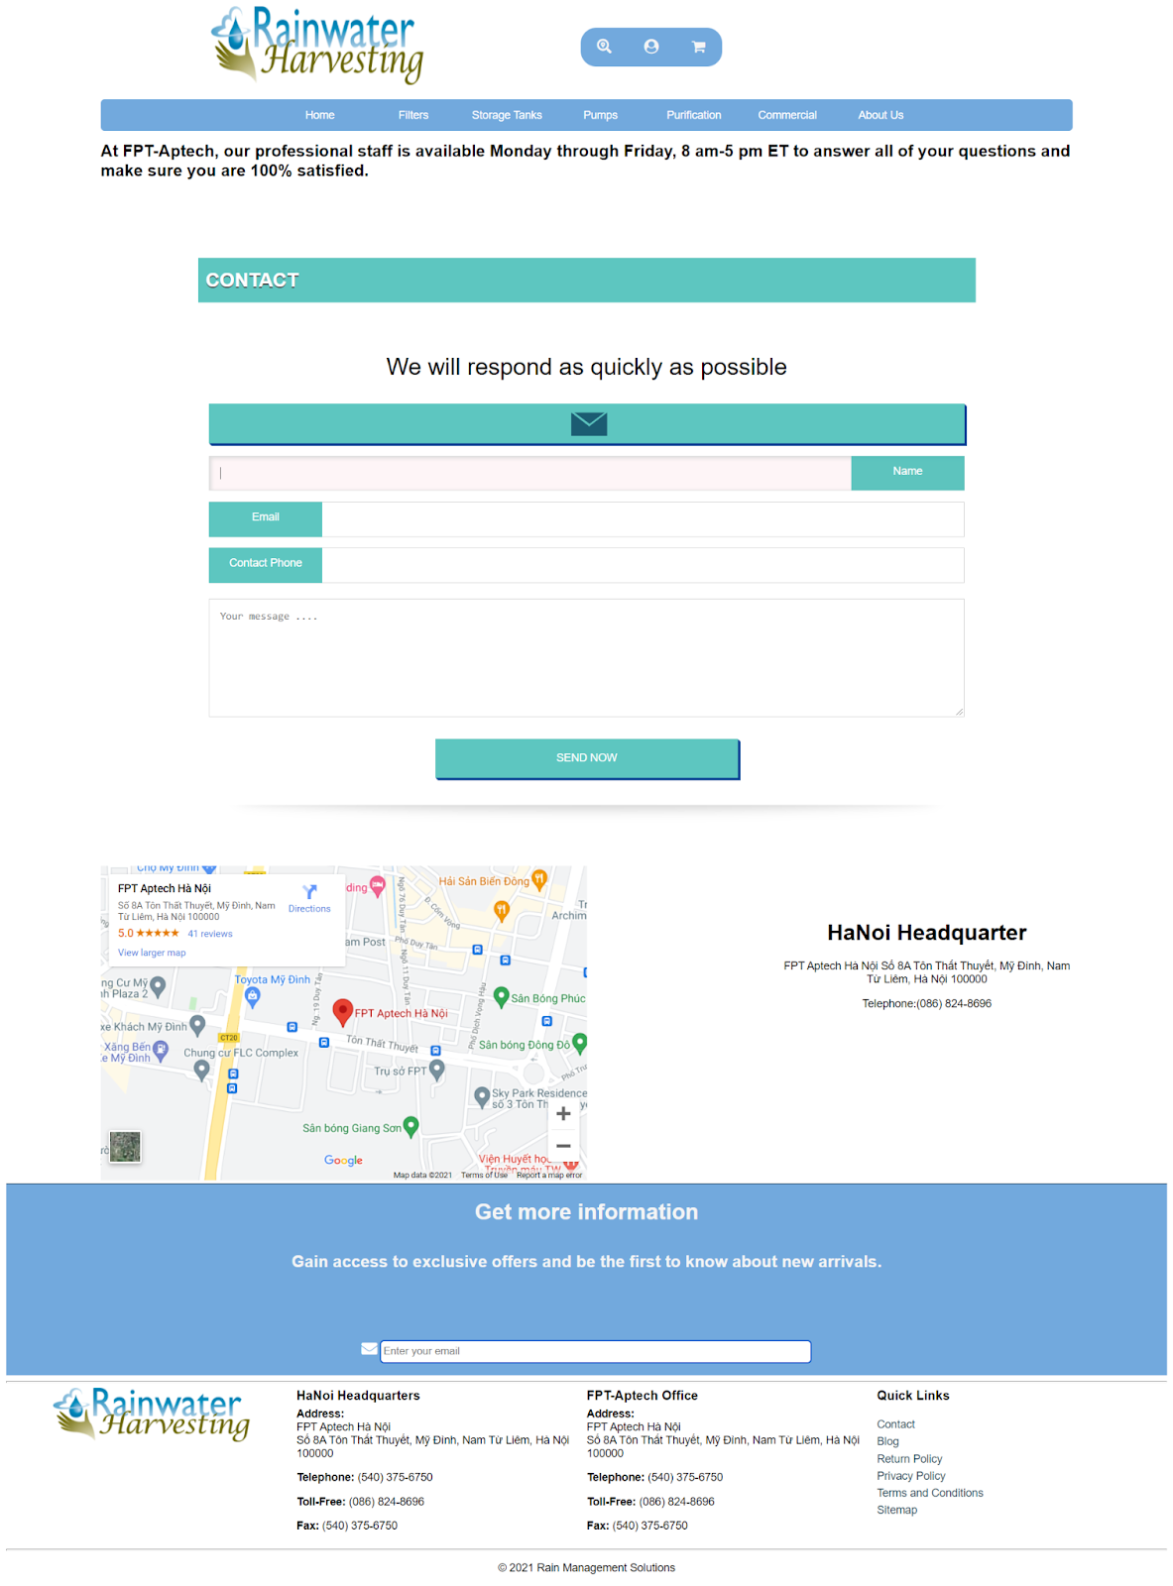

**3.6.  Check out form**

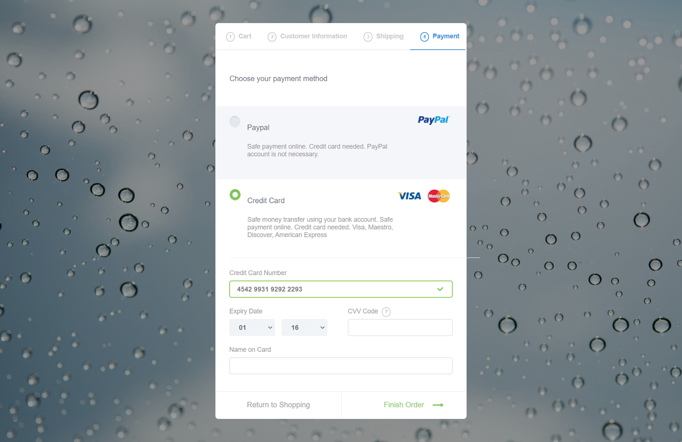

**3. Database ( null )**

**4. Summary**

